Overview
MIC2 seeks proposals for the consolidation and upgrade of its Oracle database infrastructure. The current environment supports critical workloads (Mediation, Oracle EBS, Data Warehouse (DWH), CDRs ; check table1 ) and operates on legacy, siloed, and aging infrastructure. The goal is to replace it with a unified, and highly available architecture using Oracle RAC and modern hardware.
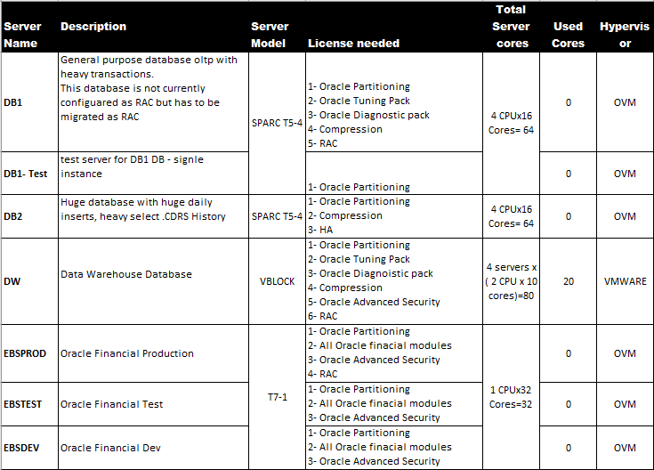
Table 1: Current Oracle environment
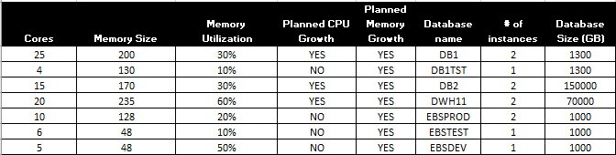
Table 1: Current Oracle environment

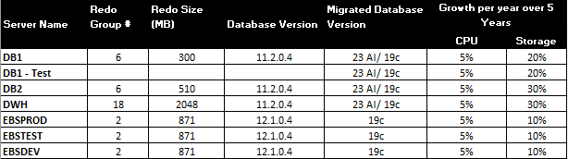
Table 1: Current Oracle environment

Project Objectives
- Modernize infrastructure using the latest Oracle Database release (e.g., Oracle 19c, 23AI).
- Acquire the appropriate number of Oracle licenses needed to implement the new solution and ensure its legal and compliant usage, given that all existing Oracle licenses have expired.
- Consolidate workloads with isolation between Mediation, EBS, CDRs and DWH systems.
- Ensure high availability with active-active Oracle RAC for all major workloads.
- Improve database and query performance, leveraging high IOPS and low-latency storage
- Support future scalability for 5 years, with modular expansion options.
    - This includes having headroom in compute, memory, storage capacity, and IOPS to handle increasing demand, as well as the ability to expand (for example, adding more nodes or storage) in a modular fashion
- Optimize cost over 5 years (TCO), including licensing and operational efficiency. Any refresh for EOSL system during the 5 TCO years should be taken into consideration: price and implementation process.
- Ensure the design follows Oracle and telecom best practices, supports security and IT policies.

These objectives serve as guiding principles for the project. Bidders should explicitly address how their proposed solution and implementation plan will fulfill each of the above objectives.

Scope Of Work
- Detailed Design and Planning: Architecture planning including hardware, virtualization, clustering (if used), and workload isolation diagrams.
- Environment Setup and Provisioning: Installation and configuration of servers, Operating System (preferably Oracle Linux or a compatible Linux distribution certified for Oracle), storage, and networking.
- The Bidder should verify that the proposed hardware would physically and logically fit into our existing data center environment (check annex 2 for MIC2’s data center description). If an engineered system is proposed, the vendor shall be fully responsible for the physical re-racking, installation, configuration, and integration of the proposed engineered system (including but not limited to Oracle Exadata, or any equivalent solution). All implementation activities must be performed by certified and experienced technical personnel from the vendor’s team or its official support/implementation partner (e.g., Oracle Advanced Customer Services – ACS – or equivalent).
- Redundancy: Build design redundant into every layer (dual power, dual network paths, Dual network cards, RAID storage, etc…), eliminating any single point of failure.
- Oracle Database Setup: Installation of Oracle RAC clusters for Mediation, EBS, and DWH workloads using Oracle Maximum Availability Architecture (MAA) best practices.
- Migration: Execute database migration with minimal downtime (refer to table 1) using tools like RMAN, Data Guard, or GoldenGate. Prior to migration, a pre-migration testing phase should be conducted on the new environment using non-production copies of the databases to validate compatibility and performance. The actual production cutover must be carefully orchestrated, ideally during a maintenance window provided by MIC2, to ensure continuity of business operations.
- EBS Databases migration will not be part of the project. The Bidder is responsible of full server preparation and configuration for all EBS servers to be ready for future migration.
- Post-Migration Testing (AWR Analysis): A detailed AWR analysis report and summary of results should be provided to confirm that the new platform meets the expected performance criteria. The expectation is at least a 25%-35% improvement in large query and heavy batch processing time at same interval time and same conditions. The Final Acceptance Certificate (FAC) won’t be signed until the new platform is confirmed to meet the expected performance criteria, which will be jointly defined with the MIC2 team ; for example:
Use Case | Description
OLTP – Mediation | High-frequency insert/update on CDR tables
Reporting – DWH | Complex joins, aggregations, and full scans

- In the event that the deployed solution fails to meet the expected performance after go-live, the bidder shall be fully responsible, at their own cost, for supplying and implementing any additional hardware, software, or licenses required to achieve compliance.
- High Availability & Failover Testing: As part of the implementation, the Bidder must perform thorough HA testing. This includes simulating failure scenarios (such as shutting down one RAC node, failing over network links, storage controller failures, etc.). Test plans should cover node failover, recovery times, and transparency of failover to the applications. Similarly, if the design includes backup/restore components, those must be tested (e.g., performing a restore from backup).
- Backup: The proposed solution should be compatible with MIC2's Backup environment “EMC Networker and Data Domain”.
- Security: The Bidder will harden the infrastructure (for example, applying the latest patches (OS and DB), disabling unnecessary access and ports, and ensuring only secure protocols are used (SFTP …)). (Check Table 2: Oracle Software and Licensing).
- Documentation: As part of deliverables, the Bidder must provide comprehensive documentation for the solution. This includes:
  - Design Documents: Covering the architecture, configuration settings, network diagrams, storage layout, and any specific tuning parameters.
  - Installation and Configuration Guides: Detailing how the environment was set up, for future reference in case reconfiguration is needed.
  - Testing Reports: Results of the pre/post-migration tests, AWR analysis, and HA failover tests performed.
  - Operational Procedures: Covering routine tasks such as startup/shutdown of RAC clusters, backup and recovery procedures, monitoring guidelines, and troubleshooting common issues.

- Knowledge Transfer Sessions: The Bidder will conduct training sessions or workshops with our IT operations team to hand over the management of the new environment. This should include explaining the architecture, demonstrating administrative tasks, and reviewing the documentation.
Bidder to include in led class training seats including accommodation and travel costs:
- 4 seats Oracle University in led class training on proposed Oracle Database technology and features.
- 4 seats on HCI (Hyper Converged Infrastructure) if proposed fundamental and advanced.
- 2 seats to cover Hyper Visor if virtualized solution is proposed
- 4 Seats to Cover Administration on Storage fundamental and advanced if new storage will be introduced in MIC2’s Data center.
- In addition to any needed related courses;
- The offer should include 3 years onsite premium support and maintenance / warranty on provided solution for products and services with back-to-back support with the Vendor. The warranty/support period on Hardware (server & storage) starts after the Provisional Acceptance Certificate issuance by MIC2.
- The Vendor shall provide onsite premium support and maintenance on all storage infrastructure for 2 years after the 3 years warranty and support, and specify the yearly cost.
- Solution must support minimum 5 years growth (CPU, RAM, IOPS, storage...) as specified in above Table 1, and the Bidder should provide a 5-years TCO cost breakdown, including hardware, software, services and support costs per year.
- The bidder shall provide the latest version or model of each hardware item, ensuring compatibility with the proposed software (provide certificate) and provide a vendor-issued certificate confirming a minimum product lifecycle of five years, starting from the date of the Provisional Acceptance Certificate (PAC).
- Project Management: Provide a project manager and coordinate with MIC2 team on schedules, deliverables, and risks.
All aspects of the scope above are considered mandatory requirements unless explicitly marked otherwise. Bidders must ensure their proposals cover each item comprehensively. Any deviations or exceptions must be clearly stated and justified.

Technical Specifications
This section details the technical requirements for the new Oracle database infrastructure. The Bidder’s proposed solution must meet or exceed these specifications. The requirements cover compute, memory, storage, network, virtualization, and Oracle software considerations, among others. The provided infrastructure should comply with the specifications in annex 1 to insure acceptable performance.

Compute (Servers/CPU):
The solution shall utilize enterprise-grade, high-performance servers based on the latest generation x86-64 processors. Each server should be equipped with redundant components (power supplies, fans, HBAs, Network Cards, etc.) for reliability. The CPU resources must be sufficient to run multiple Oracle RAC nodes and handle peak workloads with headroom for future growth. Bidders should specify the make/model of the server hardware and the CPU specifications (number of sockets, cores per socket, base/turbo frequency).

Memory (RAM):
Sufficient memory is critical for Oracle SGA/PGA and overall database performance. Each Oracle RAC node (in each cluster) should be provisioned with ample RAM to accommodate the database instances and anticipated workload.

Storage (Capacity, IOPS, Latency):
The storage subsystem is a crucial component of this project, as it directly impacts database performance. The new solution’s storage must be enterprise-class and all-flash or a hybrid flash system that delivers extremely high I/O throughput. We require:
- Capacity: Sufficient usable storage to host all database data, index, redo, archive, and backup sets, taking into consideration free space headroom for future growth over 5 years (refer to Table 1).
- IOPS and Throughput: the storage can handle tens of thousands of IOPS per database instance with sub-millisecond latency under load.
- Connectivity and Protocol: The storage system should connect via a high-speed interface. Must be Fiber Channel end-to-end with 32Gbps minimum or 25 Gb/sec, or 100 Gb/sec Ethernet. Redundant paths from each server to storage are required (multipathing configured) with redundant fabrics to ensure no single point of failure in connectivity. In hyper- converged setup, similar redundancy at the node level must be achieved

Oracle RAC and Clustering:
As a mandatory requirement, the solution must implement Oracle Real Application Clusters (RAC) in an active-active configuration for the primary database environments (Mediation, EBS, DWH). Each of these environments will have its own RAC cluster; for example:
  - Mediation DB RAC: 2 nodes (minimum) across two separate physical hosts.
  - EBS DB RAC: 2 nodes (minimum) across two separate physical hosts.
  - DWH DB RAC: 2 nodes (minimum) across separate physical hosts (or potentially more nodes if justified for performance
  - CDRs Database must be configured as High Available cluster across two separate physical hosts.

Virtualization Platform
If virtualization is proposed, the following requirements must be strictly observed:

Supported Configurations
- The proposed virtualization platform must be officially certified or fully supported for running Oracle RAC and Oracle Database 19c/23ai (Provide Certificate).
Common platforms (such as VMware) are widely used for Oracle RAC; however, Oracle Support may require reproducing issues on bare metal systems. In such cases, the bidder is responsible for fully supporting MIC2 during troubleshooting or escalation.
- The bidder must also provide proof or references of successful Oracle RAC implementations on the proposed virtualization platform.

Resource Allocation
- Oracle VMs must have dedicated vCPU and memory assignments, with resource reservation to ensure performance consistency.
- Virtualization overhead must be minimized:
    - Account for hypervisor overhead in capacity planning.
    - The proposed virtualization solution must support Para virtualized I/O drivers or SR-IOV. Bidders must indicate whether their solution enables SR-IOV and provide configuration details or references for performance tuning.

High Availability
In a virtual configuration:
- For a RAC cluster, each RAC node should be on different physical server of the VM cluster.
- For High Available Cluster (HA), cluster nodes should be on different physical server of the VM cluster.
- Oracle VMs must have dedicated VCPU and memory assignments, with resource reservation to ensure performance consistency.

Network Infrastructure:
The network connecting the database servers (physical and virtual) to each other and to application servers/users must be high-bandwidth and resilient. Requirements include:
- Database Client Network: Redundant high-speed network interfaces for client connectivity to the databases. This might be 10 Gbps Ethernet (at minimum) for connecting to the data center core network. The vendor must include in the bid 2 TOR switches for redundancy.
- Cluster Interconnect Network: A dedicated network (25 Gbps or better) for RAC inter-node communication. Ideally, this is a physically isolated network or VLAN with redundant switching. Extremely low latency on this interconnect is required for RAC cache fusion efficiency.
- Network Latency and Throughput: Bidders should state the expected network throughput and any specific network equipment proposed. The network should be capable of handling peak loads, such as bulk data loading into the DWH or high volumes of online transactions, without packet loss or saturation.
- Management Network: the proposed solution should include at least one management switch to have a dedicated administration of solution components.

Oracle Software and Licensing
- Database Edition & Options: the following licenses should be considered:

Database | License | Number of cores
MED | DBEE, Partitioning, Diagnostic, Tuning, RAC
MED-Test | Partitioning
CDRs | Partitioning, Advanced Compression
DHW | Partitioning. Diagnostic. Tuning, RAC, Advanced Compression
EBSProd | Partitioning, RAC, Advanced Security
EBSTEST | Partitioning, Advanced Security
EBSDEV | Partitioning, Advanced Security
Oracle Internet Application Server Enterprise Edition -Processor Perpetual
Oracle Internet Developer Suite - Named User Plus Perpetual
Table 2: Oracle Software and Licensing
- Licensing Considerations: The proposal should clearly state how Oracle licensing will be handled per Database. Procurement of Oracle licenses may be handled by MIC2 separately, but the Bidder must ensure the design is compliant.
- Operating System: OS must be latest Oracle Linux (or latest Red Hat ) with UEK kernel, certified for Oracle 19c/23ai.
- All software components must be vendor-certified and supported for the proposed Oracle version.
- The proposed solution should be compatible with MIC2's Backup environment “EMC Networker and Data Domain”.
- Backup/ Recovery Tools: The Bidder should shadow backup integration and implementation and may propose a best practice backup solution based on implemented similar solutions.
- Compatibility and Integration Support: The Bidder shall provide technical support and assistance during the integration of the proposed Oracle version and platform with existing application systems, including the Mediation platform, DWH ETL processes, and BI tools. If any potential compatibility considerations are known based on prior experience or industry best practices, the Bidder is expected to highlight them and collaborate with the MIC2 team to plan appropriate mitigation or adaptation measures.
The Bidder should complement in their proposal the resource Allocation Plan (refer to Table 3) as summarized below, indicating the distribution of Database servers across the infrastructure (virtual machines or physical deployments) for each database and their resource sizing:

Workload / DB | Proposed Deployment | Licenses | Cores | RAM | Storage Size | Servers name | Storage Type | Comments
Mediation DB | 2-node Oracle RAC | DBEE, Partitioning, Diagnostic, Tuning, RAC … |  | Must be >256 GB |  |  | Shared storage (ASM diskgroup) for database files | For high OLTP inserts; must ensure low-latency storage and high redo log throughput.
E-Business Suite DB | 2-node Oracle RAC | Partitioning, RAC, Advanced Security |  | Must be >128 GB |  |  | Shared storage  (ASM diskgroup) for database files | Critical ERP system; requires high availability and strong OLTP performance.
Data Warehouse DB | 2-node Oracle RAC (2 VMs on separate hosts) | Partitioning. Diagnostic. Tuning, RAC, Advanced Compression |  | Must be >256 GB |  |  | Shared storage  (ASM diskgroup) for database files | Heavy read/query workload; ensure high throughput (consider additional nodes if needed).
CDRs DB | 2-node Oracle RAC | Partitioning, Advanced Compression |  | Must be >170 GB |  |  | ASM  (ASM diskgroup) for database files | Heavy read/query workload; ensure high throughput (consider additional nodes if needed).
Other DB workloads | 2-node Oracle RAC (2 VMs on separate hosts) (or single-instance with HA as justified) | Partitioning, Advanced Security |  |  |  |  |  | Ensure any additional DBs do not co-reside with the above critical workloads
Table 3: Resource Allocation Plan

Support SLA

Attached SLA in annex 3.

Submission Format and Evaluation Criteria
Proposal Format: We require that each proposal include the following sections (at minimum):

- Executive Summary: A brief overview of the Bidder’s proposed solution, highlighting how it meets our objectives and why the Bidder’s company is suited for this project. This should concisely summarize key points of the technical solution, differentiators.
- Bidder Profile and Experience: Background of the Bidder’s organization, including years in business, financial stability, and core areas of expertise. Importantly, the Bidder should highlight relevant experience in similar Oracle database consolidation or upgrade projects, especially for telecom or large enterprise clients. References to at least 3 similar projects (with client name/contact, industry, scope, duration, outcome). Also include below certifications
  - Partner level and status,
  - Certified Professionals on staff for this specific solution
  - Service center and delivery partnership
  - Government and public sector sales authorization.

- Technical Proposal: This is the main body of the response and should detail the proposed solution, covering all aspects from the Technical Specifications and Design Guidelines outlined in this RFP. It should include:

  - Solution Architecture: Description of the proposed architecture, including hardware, software, Solution Design, and how it meets each requirement. Include the required Visio architecture diagrams (either embedded or as an appendix) showing the design.
  - Compliance with Requirements: A point-by-point response to the requirements. Bidders may use the Compliance Matrix provided in this RFP to respond (filling in compliant/not compliant and clarifications). Additional narrative explanation should be given for how each requirement is fulfilled. It’s acceptable to reference documents or sections in the proposal where a requirement is addressed.
  - Implementation Plan: A detailed plan and timeline of how the project will be executed. Identify key phases, milestones, and deliverables. Include an estimated project schedule (e.g., in weeks or months from contract sign) for design, installation, testing, migration, go-live.
  - Testing and Quality Assurance: Describe the testing plan including the pre- and post-migration testing procedures. Specify how you will utilize AWR reports and other tools to verify performance. Outline the user acceptance testing approach and criteria for success.

- Staffing and Team: Introduce the proposed project team (project manager, lead architect, DBA,etc.), including their qualifications and experience with similar projects. Resumes or summaries can be included in an appendix.
- Financial Proposal: The financial proposal must contain a detailed cost breakdown as described in the Financial Proposal Requirements section of this RFP. No pricing information should appear in the technical proposal sections
- Compliance Matrix: The provided compliance matrix should be completed and included in the proposal. The Bidder must indicate for each requirement whether their proposal is compliant, not compliant, or partially compliant. For any non-compliance or partial compliance, an explanation or alternative solution must be provided.

Financial Proposal Requirements
The Financial Proposal must be presented clearly and in sufficient detail to allow MIC2 to understand the cost components of the solution over a 5-year period. To ensure a fair comparison, Bidders are required to follow these guidelines when preparing the financial part of their proposal:
- Itemized Breakdown: The costs should be broken down into categories, including but not limited to:
- Hardware Costs: List each major hardware component with quantity and unit price (e.g., servers, storage arrays, network switches, etc.). If the Bidder is proposing a bundle or an appliance, provide a breakdown of its constituent cost or at least the total cost for that unit.
- Software Costs: This includes costs for Oracle licenses (if the Bidder is reselling or including Oracle licenses) and any other software (e.g., virtualization software licenses, backup software, etc.). Again, specify quantities (e.g., number of Oracle Database EE licenses, RAC option licenses, etc., if applicable) and unit costs.
- Implementation Services: The cost for services to design, install, configure, and migrate. This could.be a fixed project fee or broken into phases (design, implementation, migration, etc.). Include costs for testing, training, and documentation efforts as well.
- Support and Maintenance: All recurring annual costs for support/maintenance of hardware and software for the 5-year period. This might include:
- Three years Warranty, for the proposed Hardware, free of charge must be considered.
- Hardware support contracts
- Software support or subscriptions
- Any managed services fees if the Bidder offers ongoing administration as part of support.
- Other (Optional or Miscellaneous): Any other costs not covered above, such as optional features or add-ons
- 5-Year Total Cost of Ownership (TCO): Provide a summary table that projects the costs over each of the 5 years. An example format is given below. This table should include all costs, both one-time and recurring, allocated in the year they occur.

Pricing Table Structure

Component | Year 1 | Year 2 | Year 3 | Year 4 | Year 5 | Total (5 Years)
CAPEX
Hardware Purchase
Oracle Licenses
Other Software Licenses
Storage
Other Hardware (e.g., switches, firewalls)
Other Capex ( Training, Spare parts )
OPEX
Implementation / Migration Services
Hardware Support & Maintenance (only Y4 and Y5)
Software Support ( Oracle ACS,etc.) (only Y2 to Y5)
Managed Services (if applicable)
Other Opex
Subtotal Per Year
Total Offer (5 Years)
(Note: The above is a generic example. Bidders should adapt it to their cost structure, adding/removing rows as needed.)

Annex 1
Hardware Specifications required for High Performance

Excel sheet to be added

Annex 2
Re-racking
Huawei Datacenter and cabinets descriptions
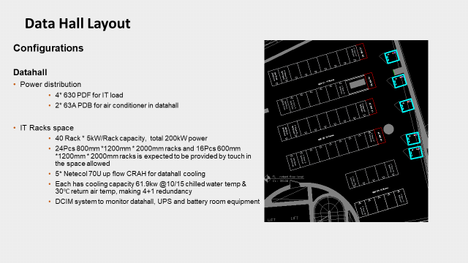

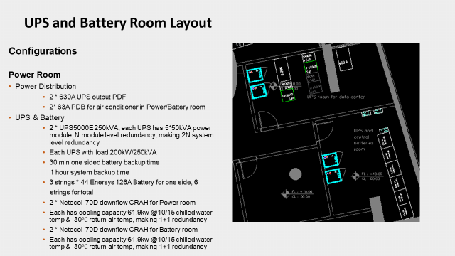

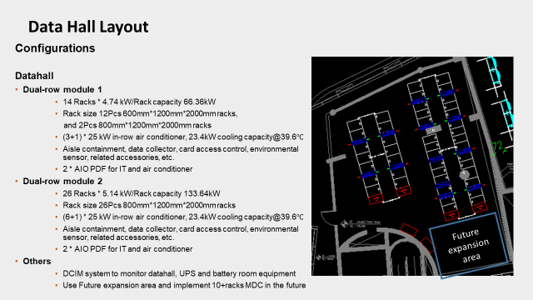

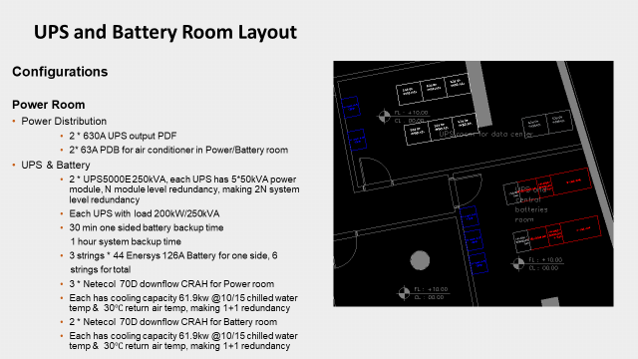

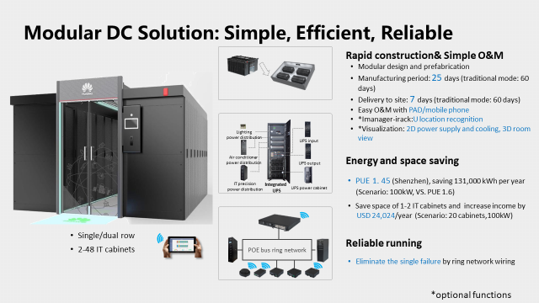

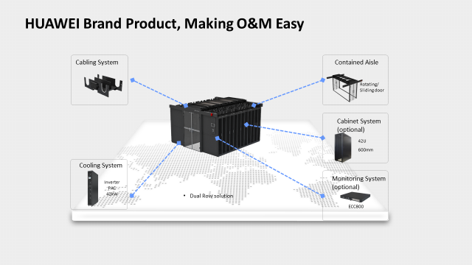

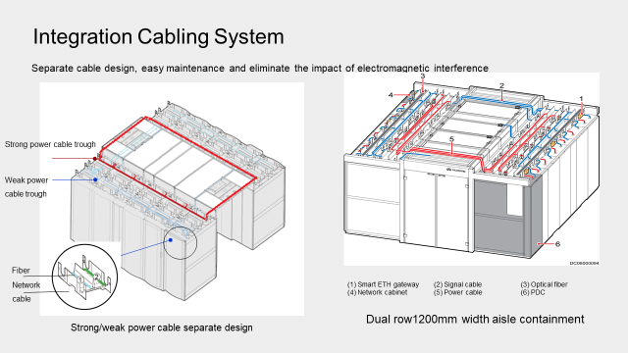

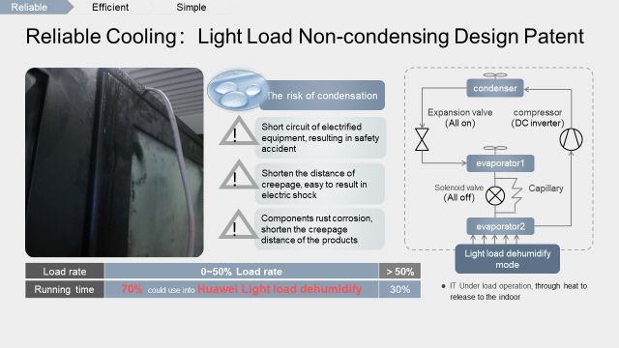

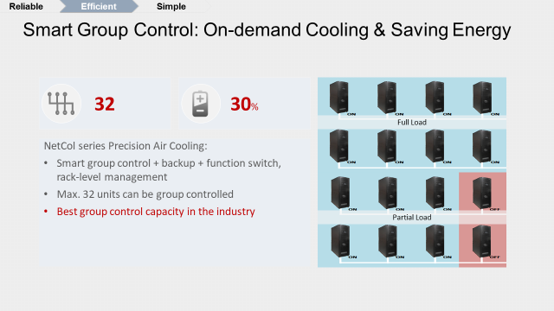

Annex 3
Service Level Aagreement

Support Services Packages

The Premier Support Services Package will include the below SLA terms:

- Single point of contact through HelpDesk.
- Service Account Manager.
- Notification of software updates and patches.
- Bug fixes.
- Release updates.
- Patches installation.
- Updates to firmware and licensed software.
- On-Site hardware problem diagnosis and resolution.
- Monthly preventive maintenance.
- Semi-annual system performance analysis and tuning.
- Annual Support Plan.
- Coverage 7 days a week, 24 hours a day.
- Response to call (2 hours).

The response time to provide services effective the escalation time shall be as follows:
- For P1 (Critical/Emergency) incidents, response time 1 hour, restoration time 3 hours, and resolution time 6 hours.
- For P2 (Major) incidents, response time 3 hour, restoration time 6 hours, and resolution time 24 hours.
- For P3 (Non Service Impacting) incidents, restoration time 24 hours, and resolution time 5 calendar days.
- For P4 (other types) incidents, restoration time 8 hours.

Support Infrastructure
The HelpDesk provides a convenient one stop support contact 24 hours a day, 7 days a week. Customers may request services via multiple channels to ensure that they get instant access to support services.
In order to serve anywhere and anytime, we make available to 24 hours customer service hotline +961 ………………...
For queries, problems, comments, call this number to be connected with someone who will immediately assist or take information and have a specialist call back.

Service Delivery Procedure
The Helpdesk is the first point of contact for any problems, queries, and/or advice associated with the maintenance and support services provided.
Designated contact persons from customer should contact the HelpDesk for any support services related to any component of the solution implemented.
The HelpDesk is manned by a dedicated coordinator who receives customer service requests and records any problems on the HelpDesk system. A systematic procedure, described below, ensures that the relevant Customer Services staff is notified immediately to take all necessary remedial actions.

Problem Reporting
The HelpDesk is operational 24 hours a day, 7 days a week.
The HelpDesk coordinator assigns a HelpDesk Reference (HDR) Number that is given to the customer for reference and follow-up. Depending on the problem, the HelpDesk coordinator classifies the problem and assigns it to the appropriate support staff:
The following information should be provided at time of logging the call at the HelpDesk:
- Name
- Location
- Telephone Number
- Equipment Type
- Full description including any error codes and messages

Priority Definition

Priority 1 – High Priority
An acute problem for a group of users, or all users, causing a major interruption to normal business activities, typically:
- Main System unavailable.
- Major communication node failure or multiple node failure.
- Major degradation in system performance.
- LAN failure.
- Application software or one of its major modules unavailable.
- Virus report.
- Security incident involving suspected improper access to information system.

Problems categorized as Priority 1 require a rapid response with a sustained effort to make a temporary correction that reduces the negative effect on normal operations, until a permanent correction can be implemented. It may also require adjustments or re-configuration of Licensed Programs, which may be accomplished remotely or on-site.

Priority 2 – Medium Priority
A problem causing concern to a user or small group of users and affecting normal business activities, where no suitable alternative is available, typically:
- Minor communication node failure no alternative available.
- Minor degradation in system performance.
- Application programs failing to fulfill any part of the specifications.

Priority 3 – Low Priority
A problem causing minor concern to a user but not seriously affecting business activities, or a more serious problem but where an alternative is available, typically:
- A peripheral device failure, alternative available.
- PC/Terminal failure, alternative available.
- Minor communication node failure, alternative available.
- Application module unavailable, alternative available.

Priority 4 – Non-Urgent
A request to carry out work or improve or change a service at a later time, typically:
- Request for enhancements to application functionality.
- Requests to move equipment.
- Consultancy queries.
- Usage queries.

Progress against all calls is reviewed on a daily basis and, where appropriate, progress information relayed to the caller. For Priority 1 and 2 calls, feedback is given every 2 hours. Call originators are provided with information on request on progress by quoting the HDR number.

Problem Life Cycle
At any point in time the problem will have a status value which indicates, in general terms, the point in its life cycle that the problem has reached. These status values are indicated in the following table:

Status | Life Cycle Point
Open | Call is logged and HelpDesk Reference Number (HDR) is issued to Customer
In-Hand | A Customer Services engineer has taken charge of the problem for investigation
Sign-Off | Problem has been resolved, awaiting confirmation from user that the problem has been satisfactorily resolved
Waiting | Before work can continue an action needs completing by external resources (e.g. waiting for spares or a software patch from the manufacturer

Problem Escalation Procedure
Whenever a problem is logged at the HelpDesk, after initial assessment, it is classified and assigned a priority, as described above, and according to the classification and impact assigned to the appropriate support staff. The support staff calls the customer who reported the problem for further clarification on the problem. The engineer first tries to solve the problem over the phone, if this is not possible he attends to the problem on-site.
The first-line support staff are capable of resolving most problems at customer sites. In special circumstances, a systematic procedure ensures that problems are escalated immediately to second-line support staff for expert advice and assistance.
In order that problems are fixed as quickly as possible and so that there is a satisfactory level of awareness of problems that remain outstanding, levels of escalation apply. This ensures that, as problems remain unresolved, the status of the problem is visible to increasingly higher levels of customer and management. These people investigate the problem to ensure that sufficient resources are allocated to resolve it.
Note that these procedures do not apply to problems with a status of ‘Waiting’. These are problems that are no longer impacting service, but have a lower priority action remaining that needs to be completed before the call can be cleared. Waiting calls are monitored separately to ensure that they do not remain at this status for an unnecessarily long time.

Problem Resolution
- Once a problem is resolved to the satisfaction of the customer, an Incident Report is generated by the support engineer and signed by the customer.
- The HelpDesk Coordinator will close the incident only when a customer signed incident report is received.
- Once the problem is closed the status is changed to Cleared, effectively closing the incident.

