Dear Vendor,

Kindly send your best priced quotation for the supply of waveguides from different frequencies, IF cables, and their related accessories to support the maintenance and implementation of microwave transmission links.
These materials will be used for corrective and preventive maintenance activities on live microwave sites to ensure continued link availability and performance.
Item description | Quantity
Microwave Accessory,Flexible Waveguide,18/23/26G,0.9m,PBR220,With English doc | 24
Microwave Accessory,Flexible Waveguide,28/32/38G,0.9m,PBR320,With English doc | 24
Microwave Accessory,Flexible Waveguide,15G,0.9m,PBR140,With English doc | 24
Microwave Accessory,Flexible Waveguide,10/11G,1.8m,PBR100,With English doc | 8
Microwave Accessory,Flexible Waveguide,10/11G,0.9m,PBR100,With English doc | 8
Twistflex Hanger | 200
Coaxial Cable, Copper-clad Aluminium Wire,50ohm,7.6mm,4.8mm,1.8mm, Black, 5D | 20,000 meter
Patch Cord Accessories of Double IF (5D) | 200

Below are the technical specs for the waveguides required:

Parameter | Specification
Type | Flexible rectangular microwave waveguide
Application | Microwave transmission maintenance
Length | 0.9 meters
Frequency Range | As specified for each requested frequency band
Waveguide Size | Standard WR series corresponding to the operating frequency
Material | High-conductivity brass or copper with corrosion-resistant finish
Flanges | Standard IEC/CPR/UBR or equivalent, factory assembled
VSWR | ≤ 1.15:1
Insertion Loss | Low-loss design as per manufacturer's specifications
Operating Temperature | -40°C to +70°C
Environmental Protection | Suitable for indoor and outdoor installations

All waveguides should be compatible with Andrew and HATA antennas.
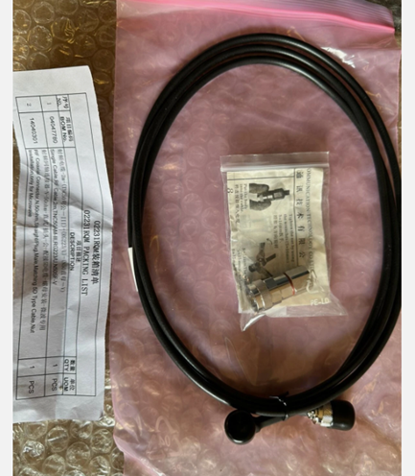
Suppliers should provide a sample for technical acceptance.
The sealed envelope should be submitted by hand no later than Monday 3 August 2026 before 12:00 PM and marked visibly with the reference TechProcurement /WAVEGUIDESIF /24/7/2026 and submitted
to the following address:
Procurement Department 8th floor
Beirut Central Building (Touch Building)
Plot # 1526 / Bashoura - Block B
Fouad Chehab Avenue
Beirut
PO. BOX 175051

For contact: Mohamed 70 703 181

Best Regards,

